# Project Proposal

Project: Bomberman

Package to Use: pygame, and maybe socket

This project is aimed to design a project like a classic game once popular in 1990s named Bomberman. If time allows, I would be more than willing to develop into a multiplayer game, which allows two players to play with each other.

I will use pygame to finish the graphic part and probably will use socket to solve the Internet connection and communicate with another computer.

According to the video, I found the wall always in the odd column and odd row, and the left top corner of three blocks are always empty and so players can start normally.

# Competitive Analysis

Bomberman has evolved a lot since its first version released. Some have the 3D version (actually it’s 2.5D, users can’t change their perspective); some have a higher resolution picture; some have supported multiplayer running. If time permits, I would like to do them all.

The first step is to realize the 2d version, then use sockets to establish connection between and finally try to implement the 3D version.

Basically, the single player mode will cover almost every detail in the original version.

1. Walls, bricks
2. A Door in every level
3. Bombs, of course
4. Bonus life
5. Power up

The wall will be fixed on odd rows and odd columns; bricks will be randomly generated, every stage has a door to enter next level, maybe in the bricks (which is invisible) maybe on the ground which is visible; the bombs will be deployed by users; the bonus life will in the brick once in one level;

Also, there are several interesting features in other game. I want to adding different bombs is a good idea. Like freeze bombs, or a bomb can destroy everything, including walls, or remote bombs. Things like that can make the game more fun.

# Storyboard

1. When the game run, it will first draw a title screen to let users to choose the modes:

|  |
| --- |
|  |
|  |

Figure title Screen

1. The following scratch is for the single player mode

|  |
| --- |
|  |
|  |

Figure the sigle plyaer version: <https://www.youtube.com/watch?v=OHXY_6s1srk>

1. The following scratch is for the multi-player mode

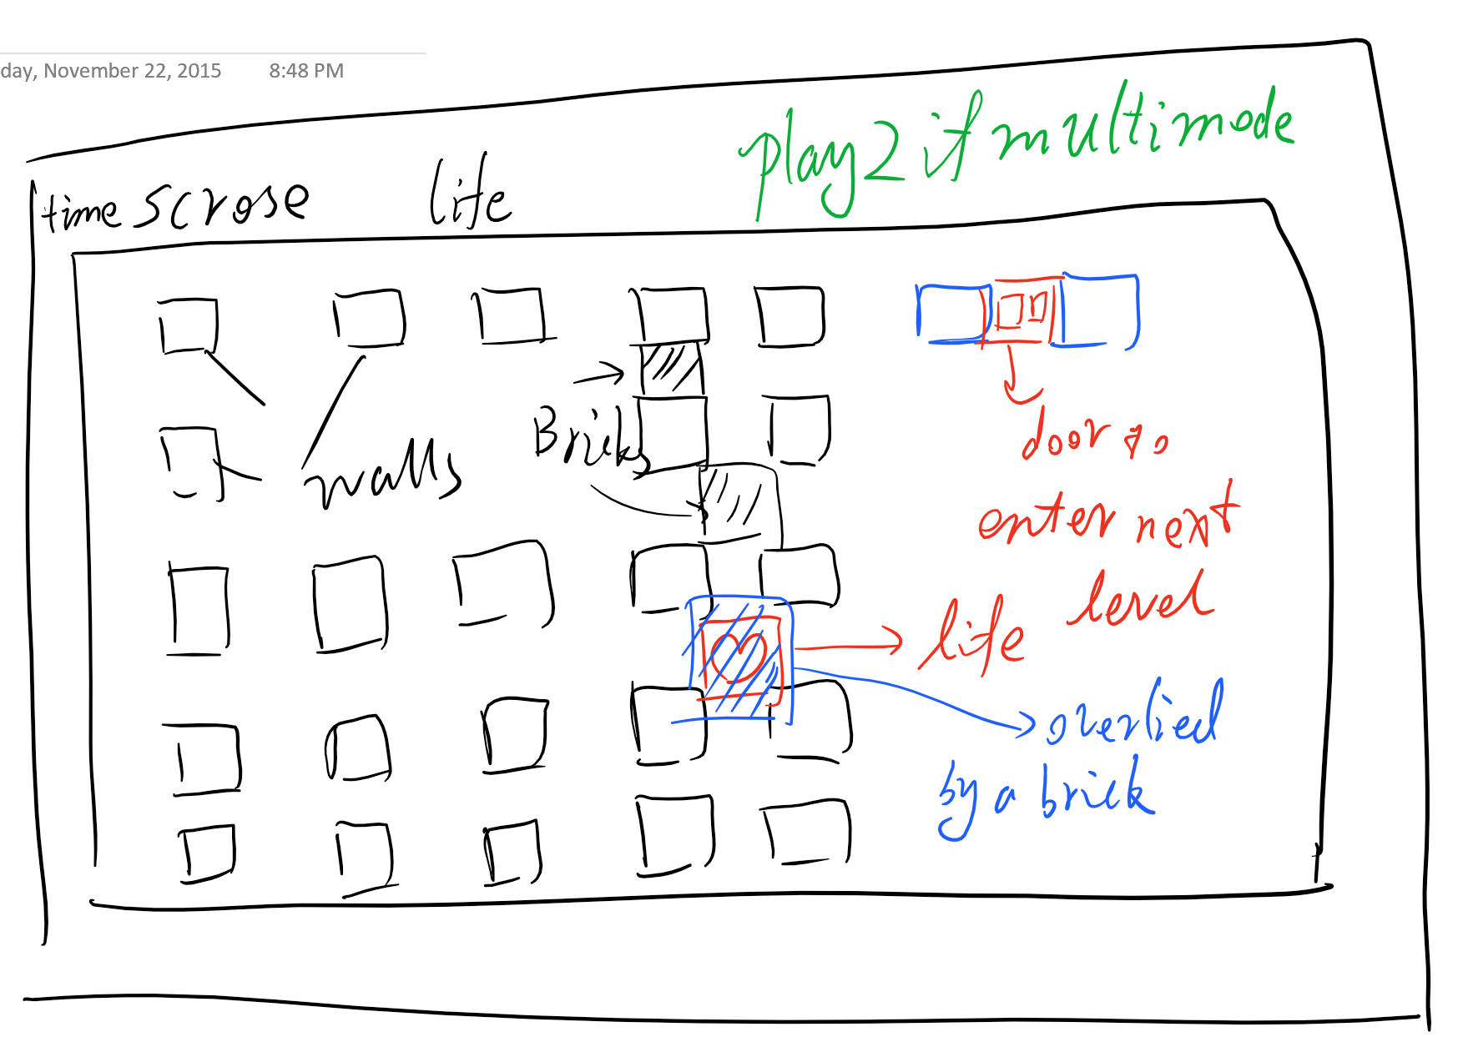

# Reference

<https://github.com/rickyc/bomberman-pygame>

Most images and sounds will come from here…